PORTFOLIO
Purna Chandra Rao Chimata
Python Full Stack Developer
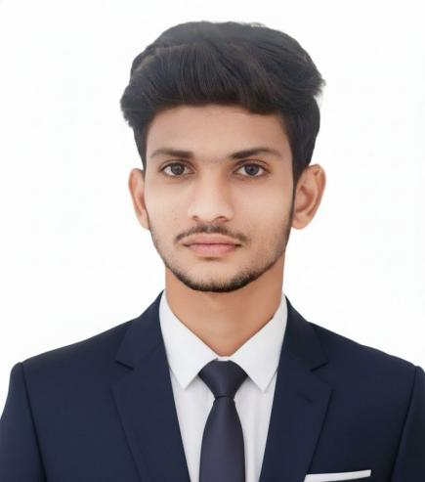
Chennai, India | purnachandraraochimata@gmail.com | +91 89195 00899
linkedin.com/in/purnachandraraochimata | github.com/Purnachandraraochimata
August 2026

TABLE OF CONTENTS
1. About Me 3
2. Technical Skills 3
3. Professional Timeline 4
4. Projects 4
5. Certifications 6
6. Contact 6

1. ABOUT ME
I am a B.Tech graduate in Computer Science and Engineering. I build practical solutions with Python, HTML, and SQL, and I am learning more about web development and artificial intelligence every day. My work spans projects in AI, IoT, and secure medical image processing, and I keep my pages simple, easy to read, and professional.
My focus is on turning technical skill into practical, understandable outcomes — whether that is a machine-learning framework that protects sensitive healthcare data, an IoT system that automates farm decisions, or a clean, well-structured web page. I value readable code, clear documentation, and continuous learning.

What I Enjoy
Watching Movies  Enjoy stories that inspire creativity and design. | Playing Games  Strategy games build logic and persistence. | Building Webpages  Creating clean and user-friendly pages is my passion.

2. TECHNICAL SKILLS
A breakdown of my proficiency across core languages, tools, and platforms:
HTML  90% | CSS  95% | Python  85%
SQL  80% | Git & GitHub  80% | OOP  75%
AI & Machine Learning  65% | Cloud (AWS)  70% | Networking (CCNA)  70%

Tools & Concepts
- Programming Languages: Python, SQL
- Web Technologies: HTML, CSS
- Concepts: Object-Oriented Programming, Machine Learning, Artificial Intelligence
- Version Control: Git, GitHub
- Development Tools: VS Code, Google Colab
- Cloud & Networking: AWS Cloud Foundations, CCNA Fundamentals
- Soft Skills: Communication, Problem Solving, Teamwork

- PROFESSIONAL TIMELINE

2022 – 2026 — B.Tech, Computer Science & Engineering
Vel Tech Rangarajan Dr. Sagunthala R&D Institute of Science and Technology, CGPA 8.04 / 10.

2020 – 2022 — Intermediate (MPC)
Narayana Junior College, Andhra Pradesh — Score: 85.4%.

2019 – 2020 — SSC
Akshaya Vidyalayam, Andhra Pradesh — Score: 95.83%.
4. PROJECTS
Showcasing academic and personal projects in full-stack development and applied AI.

4.1 MEDISEC ML
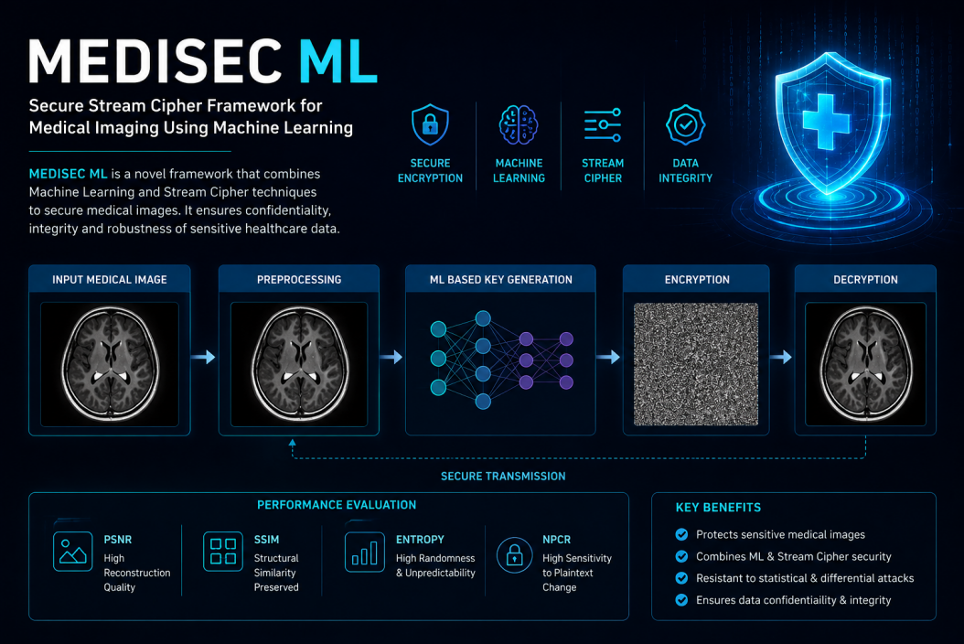
Secure Stream Cipher Framework for Medical Imaging Using Machine Learning
MEDISEC ML is a machine learning-based secure stream cipher framework designed to protect medical images. Medical imaging data — MRI and CT scans in particular — carries highly sensitive patient information, so the project's core goal is to keep that data confidential and unaltered as it moves between systems, without sacrificing the image quality clinicians depend on.
The framework follows a five-stage pipeline: the input medical image is first pre-processed, then a machine learning model generates an encryption key tuned to the image's own characteristics, the image is encrypted using a stream cipher built around that key, and finally the same key drives decryption to reconstruct the original image for authorized viewing. This ML-based key generation step is what distinguishes the framework from a conventional fixed-key cipher — it makes each encryption pass more resistant to pattern-based attacks.

Security Evaluation Metrics
The framework's effectiveness is validated using four standard image-security metrics:
- PSNR (Peak Signal-to-Noise Ratio) — measures reconstruction quality after decryption, confirming the recovered image is faithful to the original.
- SSIM (Structural Similarity Index) — checks that structural detail in the decrypted image is preserved, which matters for diagnostic accuracy.
- Entropy — measures the randomness of the encrypted image; higher entropy indicates the encrypted output reveals nothing about the original content.
- NPCR (Number of Pixels Change Rate) — tests sensitivity to small changes in the original image, showing the cipher's resistance to differential attacks.

Key Benefits
- Protects sensitive medical images throughout storage and transmission
- Combines machine learning with stream cipher security for adaptive key generation
- Resistant to statistical and differential cryptanalysis attacks
- Preserves data confidentiality and integrity end-to-end
Technologies: Python, Machine Learning, TensorFlow, OpenCV, Image Encryption
Repository: github.com/Purnachandraraochimata/medisecml

4.2 IoT Based Fertilizer System for Smart Agriculture
This project applies IoT sensing and automation to precision agriculture. Sensors continuously monitor soil moisture, pH, and nutrient levels in the field, streaming that data to a central system that evaluates crop needs in real time.
- Developed an IoT-based system to monitor soil moisture, pH, and nutrient levels.
- Automated fertilizer recommendations to improve agricultural efficiency and reduce waste.
- Performed system testing and debugging to ensure field-level reliability.
By automating the recommendation step, the system reduces reliance on guesswork or fixed fertilization schedules, helping ensure nutrients are applied only when and where the soil data shows they are needed.

4.3 AI-Based Healthcare Transportation Management System
This project applies machine learning to the logistics of emergency and non-emergency patient transport. The goal is to reduce response time and improve reliability in healthcare transportation networks.
- Developed an AI-powered transport management system for healthcare services.
- Applied machine learning techniques for route optimization and predictive analysis.
- Improved emergency response efficiency through intelligent transportation planning.
Route optimization draws on predictive modeling to anticipate traffic and demand patterns, so vehicles can be positioned and dispatched more effectively — directly supporting faster emergency response.
4.4 Portfolio Website
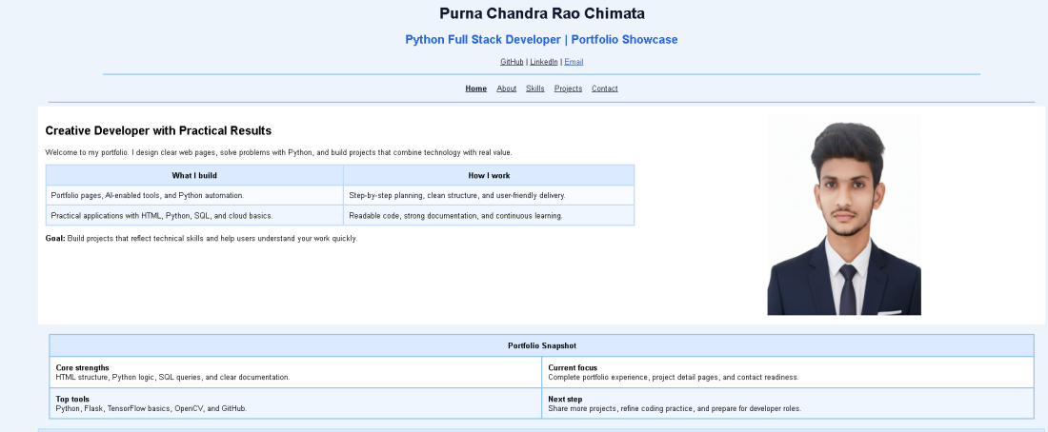
A personal portfolio website built entirely with HTML, presenting my projects, skills, and contact information in a clear, uncluttered format. It reflects the same design principle I apply to all my work: keep it simple, readable, and professional, and let the content speak for itself.
Technologies: HTML

5. CERTIFICATIONS
- AWS Academy Cloud Foundations
- CCNA Fundamentals
- Generative AI for Beginners
- Data Analytics Certification
- Design Drones for Smart Applications

6. CONTACT
Feel free to connect with me through GitHub, LinkedIn, or email.
GitHub  github.com/Purnachandraraochimata | LinkedIn  linkedin.com/in/purnachandraraochimata | Email  purnachandraraochimata@gmail.com

